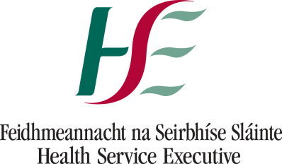

Safeguarding Adults at Risk of Abuse E Learning Module - Personal Action Plan for Staff
Staff Name: ________________________ Date: ________________
On completion of the Safeguarding Adults at Risk of Abuse E Learning Module, complete this action plan and agree it with your line manager.
Who is the person responsible for safeguarding in your service?
___________________________________
In their absence who do you to report a safeguarding concern to?
___________________________________
What are the most significant learning points of the Elearning module Safeguarding Adults at Risk of Abuse for you?
1.

2.

3.

How are you going to translate this learning into action in your workplace and within what timescale?
1.

2.

3.

